

SENIOR CITIZEN COMPANIONSHIP and TASK-ASSISTANCE APP
Architecture Design Analysis Report
Submitted in the partial fulfilment for the Course of
CSA1012- Software Engineering
to the award of the degree of
BACHELOR OF ENGINEERING
IN
Artificial Intelligence and Data Science
Submitted by
Harshini P R (192524165)
Under the Supervision of
Dr K Anita Davamani

SIMATS ENGINEERING
Saveetha Institute of Medical and Technical Sciences
Chennai-602105




Table of Contents

Table of Contents 1
3. Introduction 1
3.1 Background 1
3.2 Problem 1
3.3 Scope 1
3.4 Objectives 1
4. System Requirement Analysis 1
4.1 Functional Requirements 1
4.2 Non-Functional Requirements 1
4.3 Stakeholders 1
4.4 Assumptions 1
4.5 Constraints 1
4.6 Quality Attributes 1
5. Software Architecture 1
5.1 Why Chosen 1
5.2 Advantages 1
5.3 Limitations 1
5.4 Comparison with Alternative Architectures 1
6. Architecture Diagram 1
7. Components 1
7.1 Camera Layer 1
7.2 Edge Processing 1
7.3 AI Detection 1
7.4 Inventory Service 1
7.5 Analytics 1
7.6 Alert Service 1
7.7 Prediction Engine 1
7.8 API Gateway 1
7.9 Authentication 1
7.10 Dashboard 1
7.11 Database 1
7.12 Notification 1
7.13 Component Responsibilities 1
8. Component Interaction 1
9. Database Design 1
9.1 Entity Descriptions 1
9.2 Database Schema 1
10. APIs 1
11. Quality Attribute Analysis 1
11.1 Scalability 1
11.2 Security 1
11.3 Performance 1
11.4 Reliability 1
11.5 Availability 1
11.6 Maintainability 1
12. Architectural Decisions 1
14. Conclusion 1

- Executive Summary

The Senior Citizen Companionship and Task-Assistance App is a smart mobile application developed to improve the quality of life of elderly individuals by providing companionship, health assistance, reminders, emergency support, and communication services.
Many senior citizens live alone due to migration of family members or busy lifestyles. This often results in loneliness, missed medications, unmanaged health conditions, and delayed emergency responses.
The proposed system integrates Artificial Intelligence with healthcare and communication technologies to offer a personalized digital companion. The application reminds users about medications, doctor's appointments, daily activities, and exercise schedules while also enabling instant communication with caregivers and family members.
The application further includes emergency SOS functionality, mood tracking, voice-based interaction, location sharing, health monitoring, and task management. AI-powered conversational assistance provides emotional support and answers common health-related questions.
The system is intended for senior citizens, caregivers, healthcare professionals, and family members, providing a secure and user-friendly platform that promotes independent living while ensuring continuous monitoring and assistance.

2. Industry Context

The global elderly population is increasing rapidly due to improved healthcare and higher life expectancy. According to international health organizations, millions of senior citizens experience loneliness, depression, memory loss, and difficulties managing daily activities.
Digital healthcare applications are becoming essential tools for elderly care by offering medication reminders, health monitoring, emergency alerts, and virtual companionship.
Several healthcare providers and technology companies have introduced AI-powered solutions to improve elderly care. However, many existing systems focus only on health monitoring while neglecting emotional well-being and daily task assistance.
The Senior Citizen Companionship and Task-Assistance App combines healthcare management, emotional companionship, and intelligent task assistance into a single platform, helping senior citizens live safely and independently.

3. Introduction
3.1 Background
Senior citizens may require assistance with daily activities, task management, communication and companionship. Family members may not always be available to provide continuous support because of work, distance and other responsibilities. Traditional methods of coordinating assistance often depend on phone calls, personal communication and manual scheduling, which can make it difficult to track tasks and requests efficiently.
The increasing availability of mobile applications, cloud services, real-time communication and notification systems provides an opportunity to create a unified digital platform for senior citizen support.
SeniorCare Assist is proposed as a software application that allows senior citizens to manage daily tasks, request assistance, communicate with companions and receive timely reminders and notifications. The system also provides authorized family members with relevant task updates and allows companions or helpers to accept and complete assistance requests.
The application combines task management, companion matching, communication and notification services into a single platform. A scalable software architecture allows these capabilities to operate independently while communicating through secure APIs and event-based interactions.

3.2 Problem
Senior citizens may face difficulties in independently managing daily tasks such as appointments, shopping, household activities and other routine requirements. Family members may also have difficulty monitoring whether important tasks have been completed when they are not physically present.
There is no unified system in the proposed problem that combines task scheduling, assistance requests, companion matching, communication, reminders and authorized family monitoring in one platform.
Manual coordination through phone calls or messages can result in missed requests, delayed assistance, lack of task visibility and difficulty maintaining a history of completed activities.
SeniorCare Assist addresses this gap by providing a centralized platform that captures task requirements, connects users with available companions, tracks task progress and provides notifications to relevant users.

3.3 Scope
SeniorCare Assist covers the end-to-end digital workflow required for senior citizen task assistance and companionship.
The scope includes:
- Senior citizen registration and login.
- Profile management.
- Daily task creation and scheduling.
- Task priority and status management.
- Assistance request creation.
- Companion/helper matching.
- Companion request acceptance and rejection.
- Chat and communication.
- Notifications and reminders.
- Family member monitoring with authorization.
- Task history and reporting.
- User authentication and role-based access.
- Backend services and APIs.
- Database design.
- Event-driven communication between services.
The system focuses on software-based coordination and assistance management. Physical execution of tasks, professional medical services and emergency response operations are treated as adjacent services outside the core scope of this assignment.

3.4 Objectives
The main objectives of SeniorCare Assist are:
- Provide senior citizens with a simple platform for managing daily tasks.
- Allow users to request assistance for required activities.
- Match assistance requests with suitable available companions or helpers.
- Provide companionship and communication facilities.
- Send timely reminders and notifications.
- Allow authorized family members to monitor relevant task updates.
- Maintain task and assistance history.
- Protect user information through authentication and authorization.
- Provide a scalable, reliable and maintainable software architecture.
- Support future integration with additional services and applications.

4. System Requirement Analysis
The requirements for SeniorCare Assist are derived from the needs of senior citizens, companions/helpers, family members and system administrators.
The system must provide simple user interaction while maintaining secure communication, reliable task management and timely notifications.
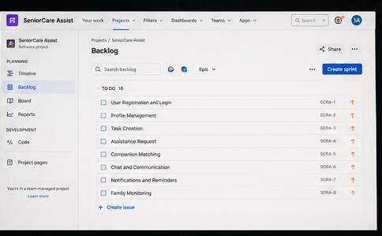

4.1 Functional Requirements
ID | Requirement | Description
FR-01 | User Registration | Allow senior citizens, companions and family members to create accounts.
FR-02 | User Authentication | Authenticate users and provide role-based access.
FR-03 | Profile Management | Allow users to create and update their profiles and preferences.
FR-04 | Task Creation | Allow senior citizens to create and schedule daily tasks.
FR-05 | Task Management | Allow users to view, update, cancel and track tasks.
FR-06 | Assistance Request | Allow senior citizens to request assistance for selected tasks.
FR-07 | Companion Matching | Identify suitable available companions/helpers for assistance requests.
FR-08 | Request Management | Allow companions to accept or reject assistance requests.
FR-09 | Companionship | Support scheduled companionship activities and sessions.
FR-10 | Chat | Allow authorized users to communicate through messages.
FR-11 | Notifications | Send task reminders, request updates and important notifications.
FR-12 | Family Monitoring | Allow authorized family members to view relevant task progress.
FR-13 | Task History | Maintain records of completed, pending and cancelled tasks.
FR-14 | Reporting | Provide task and assistance history for authorized users.

4.2 Non-Functional Requirements
ID | Category | Requirement
NFR-01 | Performance | Common operations such as login, task creation and task retrieval should respond within a short time under normal load.
NFR-02 | Scalability | The system should support an increasing number of senior citizens, companions and family members.
NFR-03 | Availability | Core services should remain available during normal usage periods.
NFR-04 | Security | User information and communication must be protected through authentication, authorization and encryption.
NFR-05 | Reliability | Task and assistance information should not be lost during normal system operation.
NFR-06 | Maintainability | Individual services should be independently maintainable and deployable.
NFR-07 | Usability | The application should provide a simple and clear interface suitable for senior citizens.
NFR-08 | Privacy | Personal information should only be accessible to authorized users.

4.3 Stakeholders
Stakeholder | Interest / Role
Senior Citizen | Creates tasks, requests assistance, communicates with companions and receives reminders.
Companion / Helper | Receives assistance requests, accepts tasks and communicates with senior citizens.
Family Member | Monitors authorized task updates and receives important notifications.
System Administrator | Manages users, roles, system configuration and reported issues.
Software Development Team | Designs, develops and maintains the application architecture.
IT / DevOps Team | Deploys, monitors and maintains application infrastructure.
System Operator | Monitors application activities and service availability.

4.4 Assumptions
- Users have access to a smartphone, tablet or computer with internet connectivity.
- Senior citizens and companions provide accurate profile information.
- Companions update their availability status.
- Family monitoring is enabled only with appropriate authorization.
- Users have access to the notification channels supported by the application.
- The application backend and database are hosted on reliable infrastructure.
- Users provide necessary task details when creating assistance requests.

4.5 Constraints
- Some senior citizens may have limited experience with digital applications.
- Internet connectivity may not always be available.
- User privacy must be protected.
- The system depends on accurate availability information from companions.
- Location-based matching, if enabled, depends on device permissions and location-service availability.
- The system coordinates assistance but does not physically perform tasks.
- Emergency situations require appropriate external emergency services rather than relying only on the application.

4.6 Quality Attributes
The following quality attributes directly influence the architecture:
Scalability, to support growth in the number of users and assistance requests;
Security, to protect personal information, account credentials and communication;
Performance, to provide quick responses for task creation, matching and communication;
Reliability, to ensure that task and assistance requests are not silently lost;
Availability, to keep important application services accessible;
and Maintainability, to allow individual services to be updated without destabilizing the complete application.

5. Software Architecture
SeniorCare Assist adopts a Hybrid Microservices and Event-Driven Architecture.
Core business capabilities such as Task Management, Companion Matching, Companionship, Notifications and Chat are implemented as independently deployable services.
Communication between services uses an event backbone for asynchronous activities, while synchronous REST APIs are used at the application boundary through the API Gateway.
This approach is suitable because task creation, assistance requests, companion matching, notifications and status changes can generate events that need to be processed by multiple services.

5.1 Why Chosen
The application contains several independent business functions that need to communicate without creating strong dependencies between all components.
For example, when a senior citizen creates an assistance request:
An event-driven approach allows these activities to occur asynchronously.
Microservices allow each major capability to be independently developed, maintained and scaled.
Therefore, Hybrid Microservices + Event-Driven Architecture is suitable for the scalability, reliability and maintainability requirements of SeniorCare Assist.

5.2 Advantages
- Independent scaling of services.
- Loose coupling between application components.
- Better fault isolation.
- Independent deployment of services.
- Suitable for real-time notifications.
- Supports asynchronous task and request workflows.
- Easier future integration.
- Allows individual services to evolve independently.
- Supports future mobile and web clients.

5.3 Limitations
- More complex than a simple monolithic application.
- Requires management of multiple services.
- Event-based communication can make debugging more difficult.
- Requires proper monitoring and logging.
- Eventual consistency may occur between some services.
- Requires additional deployment and infrastructure management.

5.4 Comparison with Alternative Architectures
Architecture | Strengths | Why Not Chosen
Layered Architecture | Simple and easy to understand. | Less suitable for independently scaling multiple business functions.
MVC | Effective for structuring application presentation logic. | Mainly addresses application/UI structure rather than distributed backend services.
Client-Server | Simple request-response model. | Less flexible for asynchronous notification and event workflows.
Monolithic | Simple deployment and initial development. | Difficult to independently scale and modify individual functions as the system grows.
Hybrid Microservices + Event-Driven | Independent scaling, loose coupling and event-based communication. | Chosen because it best fits the system requirements.

6. Architecture Diagram
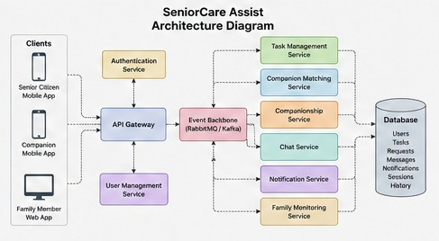

7. Components

7.1 User Interface
The User Interface provides application access to:
- Senior citizens.
- Companions/helpers.
- Family members.
- Administrators.
The interface allows users to:
- Login.
- View dashboards.
- Create tasks.
- Request assistance.
- View task status.
- Chat.
- View notifications.
- Manage profiles.
The interface should use large, clear controls and simple navigation to improve usability for senior citizens.
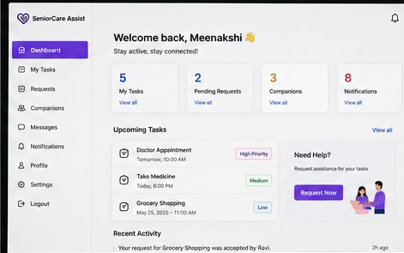

7.2 API Gateway
The API Gateway provides a single secured entry point for client applications.
It is responsible for:
- Routing requests.
- Authentication enforcement.
- Request validation.
- Rate limiting.
- Connecting clients with appropriate backend services.

7.3 Authentication Service
The Authentication Service manages:
- User login.
- Account verification.
- Authentication tokens.
- Password management.
- Role-based access control.
Different roles can include:
- Senior Citizen.
- Companion.
- Family Member.
- Administrator.

7.4 Task Management Service
The Task Management Service manages daily tasks.
It handles:
- Task creation.
- Task scheduling.
- Task modification.
- Task cancellation.
- Task status.
- Task history.
Possible task statuses are:
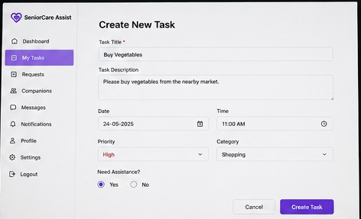

7.5 Companion Matching Service
This service identifies suitable companions for assistance requests.
Matching can consider:
- Companion availability.
- Task type.
- User preferences.
- Approximate location, when enabled.
- Companion status.
The service sends suitable requests to available companions.
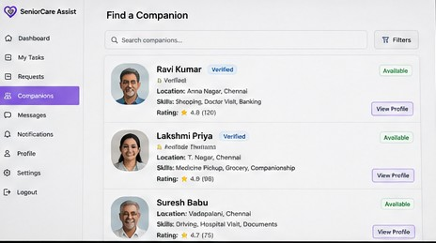

7.6 Companionship Service
The Companionship Service manages companionship activities.
It handles:
- Companion requests.
- Scheduled companionship.
- Activity coordination.
- Session status.
- Companion preferences.

7.7 Notification Service
The Notification Service sends:
- Task reminders.
- New assistance requests.
- Request acceptance notifications.
- Task completion notifications.
- Important updates.
Notifications can be delivered through:
- Push notifications.
- Email.
- SMS, where supported.
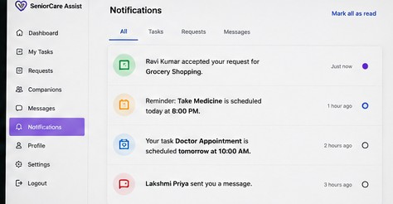

7.8 Chat Service
The Chat Service provides communication between authorized users.
It handles:
- Sending messages.
- Receiving messages.
- Message timestamps.
- Conversation history.
- User authorization.
Only permitted users should be able to access a conversation.

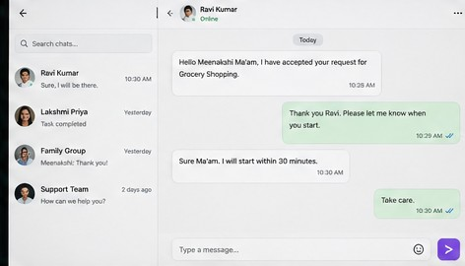

7.9 Family Monitoring Service
The Family Monitoring Service allows authorized family members to view relevant information.
It can provide:
- Task status.
- Assistance request status.
- Important notifications.
- Task history.
Access is controlled through authorization and user permissions.

7.10 Database
The database stores:
- User information.
- Task information.
- Assistance requests.
- Companion information.
- Messages.
- Notifications.
- Companionship sessions.
- Task history.

7.11 Event Backbone
The Event Backbone enables asynchronous communication between services.

7.12 Component Responsibilities
Component | Primary Responsibility
User Interface | User interaction and presentation
API Gateway | Secure entry point and request routing
Authentication | Identity and role management
Task Service | Task creation and status management
Companion Matching | Matching users with available helpers
Companionship | Managing companionship activities
Chat | User communication
Family Monitoring | Authorized task monitoring
Notification | Delivery of reminders and updates
Event Backbone | Asynchronous service communication
Database | Persistent storage

8. Component Interaction
The workflow begins when a senior citizen logs into the application through the User Interface.
The request is sent to the API Gateway, which communicates with the Authentication Service.
After successful authentication, the user can create a task.
The Task Management Service stores the task and publishes a TaskCreated event.
If assistance is required, an assistance request is created and an AssistanceRequested event is published to the Event Backbone.
The Companion Matching Service consumes the event and identifies suitable available companions.
A notification is then sent to the selected companion.
When the companion accepts the request, a RequestAccepted event is generated.
The Task Management Service updates the task status, while the Notification Service informs the senior citizen.
The task progresses through its lifecycle until it is completed.
Authorized family members can view relevant task updates through the Family Monitoring Service.

9. Database Design

The database is organised around the core entities required to manage users, tasks, assistance requests, companions, communication and notifications.
Primary keys uniquely identify records, while foreign keys establish relationships between entities.

9.1 Entity Descriptions
Users
Stores user account information, including name, contact details, role and authentication information.
Profiles
Stores additional information about users, such as preferences and basic profile details.
Tasks
Stores tasks created by senior citizens, including description, schedule, priority and status.
Assistance Requests
Stores requests made for task assistance and connects senior citizens with companions.
Companions
Stores companion availability and profile information.
Companion Sessions
Stores scheduled companionship activities.
Messages
Stores authorized communication between users.
Notifications
Stores notifications generated for users.
Task History
Stores changes and completed task records.

9.2 Database Schema

Table | Key Fields
Users | user_id (PK), name, email, phone, role, password_hash
Profiles | profile_id (PK), user_id (FK), preferences, availability
Tasks | task_id (PK), user_id (FK), description, date, time, priority, status
Assistance Requests | request_id (PK), task_id (FK), senior_id (FK), companion_id (FK), status
Companions | companion_id (PK), user_id (FK), availability, service_area
Companion Sessions | session_id (PK), senior_id (FK), companion_id (FK), start_time, end_time, status
Messages | message_id (PK), sender_id (FK), receiver_id (FK), message, timestamp
Notifications | notification_id (PK), user_id (FK), type, message, status, created_at
Task History | history_id (PK), task_id (FK), status, updated_at

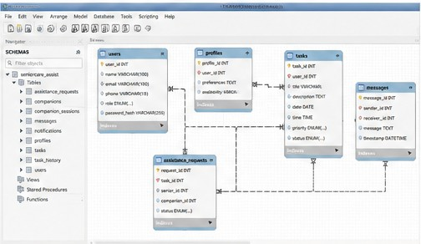

10. APIs

The API Gateway exposes representative REST endpoints for the application.
Authentication is required for protected endpoints.

Method | Endpoint | Purpose
POST | /api/auth/login | Authenticate a user and issue an access token.
POST | /api/users/register | Register a new user.
GET | /api/users/profile | Retrieve the authenticated user's profile.
PATCH | /api/users/profile | Update user profile information.
POST | /api/tasks | Create a new task.
GET | /api/tasks | Retrieve the user's tasks.
GET | /api/tasks/{taskId} | Retrieve a specific task.
PATCH | /api/tasks/{taskId} | Update task details or status.
POST | /api/assistance/request | Create an assistance request.
GET | /api/companions/available | Retrieve available companions.
POST | /api/assistance/{requestId}/accept | Accept an assistance request.
POST | /api/assistance/{requestId}/reject | Reject an assistance request.
GET | /api/messages | Retrieve authorized conversations.
POST | /api/messages | Send a message.
GET | /api/notifications | Retrieve notifications.
POST | /api/notifications/send | Send a notification.
GET | /api/family/tasks | Retrieve authorized family task updates.
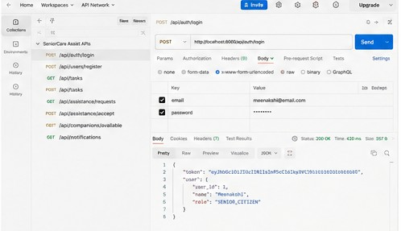

11. Quality Attribute Analysis
11.1 Scalability
Each major service can be scaled independently according to demand.
For example, if the number of assistance requests increases, the Companion Matching Service can be scaled without requiring the complete application to be scaled.
Similarly, the Notification Service can be independently expanded when the number of notifications increases.
The event-driven design supports the processing of increasing numbers of task and assistance events.

11.2 Security
Security is important because the system manages personal information and communication.
The architecture provides:
- User authentication.
- Role-based authorization.
- Secure API access.
- Encrypted communication.
- Password protection.
- Controlled database access.
- Permission-based family monitoring.
The API Gateway provides a central point for enforcing access policies.

11.3 Performance
The system should provide fast responses for common operations such as:
- Login.
- Task creation.
- Task retrieval.
- Assistance requests.
- Companion matching.
- Notifications.
Asynchronous event processing prevents one service from unnecessarily blocking another service.
For example, creating a task does not need to wait for every notification or matching operation to complete before responding to the user.

11.4 Reliability
The architecture improves reliability through:
- Persistent database storage.
- Event-based communication.
- Error handling.
- Retry mechanisms.
- Task history.
- Service-level monitoring.
If a notification service temporarily fails, the underlying task information can remain stored and the notification can be retried.

11.5 Availability
The application should remain available during normal operating periods.
Stateless services can be deployed using multiple instances.
Individual service failures should be isolated where possible so that the failure of one service does not bring down the entire application.
For example, a temporary problem with the notification service should not prevent the user from viewing existing tasks.

11.6 Maintainability
Clear service boundaries make the application easier to maintain.
For example:
- Task-related changes → Task Management Service.
- Matching changes → Companion Matching Service.
- Notification changes → Notification Service.
- Chat changes → Chat Service.
- Authentication changes → Authentication Service.
Versioned APIs and event schemas can be used to prevent changes from breaking existing components.

12. Architectural Decisions

The Hybrid Microservices and Event-Driven Architecture was selected because SeniorCare Assist contains several independent business functions that communicate through task, assistance, notification and communication events.
Event-driven communication was selected for workflows such as assistance requests, companion matching and notifications because it reduces direct dependency between services.
For example:
This prevents the Assistance Request service from being directly dependent on the complete processing of the matching and notification services.
A single API Gateway was selected to provide a unified entry point for mobile and web clients. It can centralize authentication, request routing and access control.
Microservice boundaries were created around business capabilities rather than individual technical layers. This allows services such as Task Management, Companion Matching and Notifications to evolve independently.
The main trade-off is increased architectural complexity compared with a monolithic application. However, the benefits of scalability, fault isolation, independent deployment and future extensibility make the selected architecture appropriate for SeniorCare Assist.
The architecture also supports future integration with:
- Mobile applications.
- Web applications.
- Calendar services.
- Location services.
- Smart home devices.
- Additional communication channels.

14. Conclusion

SeniorCare Assist addresses the challenges faced by senior citizens in managing daily tasks and obtaining assistance and companionship by providing a unified software platform for task management, companion matching, communication and notifications.
The proposed Hybrid Microservices and Event-Driven Architecture separates the major business capabilities into independently manageable services. The API Gateway provides a secure entry point, while the Event Backbone enables asynchronous communication between services.
The architecture directly addresses the important quality attributes identified during requirement analysis, including scalability, security, performance, reliability, availability and maintainability.
The system provides a structured workflow from task creation and assistance requests to companion matching, task completion and authorized family monitoring. The modular design also allows future enhancements and integration with additional services without requiring major changes to the core architecture.
Therefore, the proposed architecture provides a scalable, secure, reliable and maintainable foundation for the Senior Citizen Companionship and Task Assistance App.

